BIOGRAPHICAL NOTE FOR ROGELIO MARTÍNEZ MASEGOSA, MAJOR GENERAL, CHIEF OF CIVIL GUARD TRAFFIC AREA

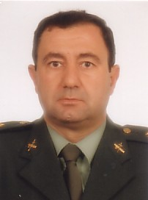
ROGELIO MARTÍNEZ MASEGOSA. Born 7 October, 1949 in Oria (Almería).
Chief of Traffic Area
Military Studies at the General Military Academy of Zaragoza and at the Special Civil Guard Academy, starting his career as Lieutenant of the Civil Guard on 15 July 1971
Degree in Law from the University of Murcia (February 1992).
Appointed Chief of Traffic Area on 24 June, 2004.
Promoted to the post of Major General on 21 October 2006.

